Wine Quality Prediction
Proposal

Dataset:
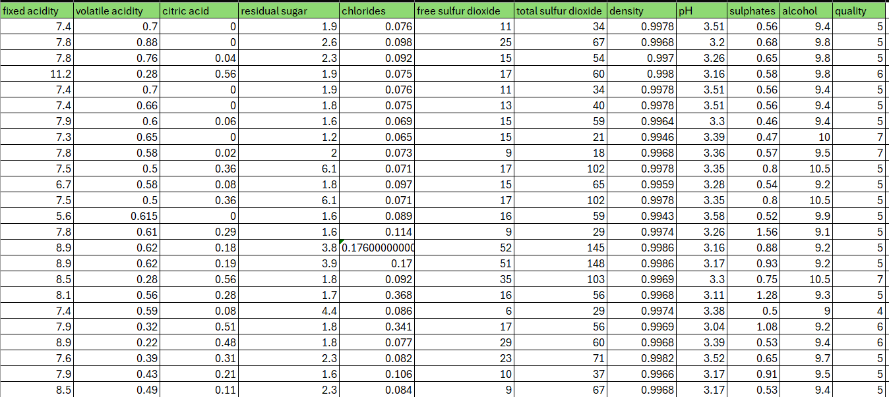
The response variable (Y) is quality.
The predictor variables (X_{i}) are fixed acidity, volatile acidity, citric acid, residual sugar, chlorides, free sulfur dioxide, total sulfur dioxide, density, pH, sulphates, alcohol.
Approach to the project:
- Create a linear regression model for Y and all Xi's.
- Evaluate correlation and pair plots to identify multicollinearity and the most influential variables on the target variable (Y).
- Check the p-values and partial F-tests for all Xi’s in the summary table and ANOVA table to see whether the variables should be added or removed. R²_{adj.} value to be checked to select the final model.
- Check the error graphs for error vs y ̂ and error vs Xi.
- If heteroscedasticity is detected in error vs y ̂, apply the transformation.
- If error graphs appear skewed, add polynomial degrees to the Xi's.
- Evaluate the performance indicators again after applying transforms and adding polynomial variables.

